**SEM imgaes:**

Zhao, J., Liu, H. & Li, X. Structure, Property, and Performance of Catalyst Layers in Proton Exchange Membrane Fuel Cells. *Electrochem. Energy Rev.* **6**, 13 (2023). <https://doi.org/10.1007/s41918-022-00175-1>

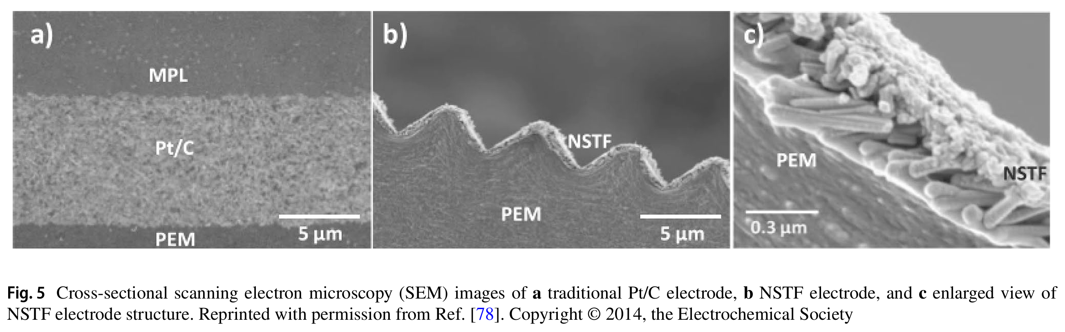

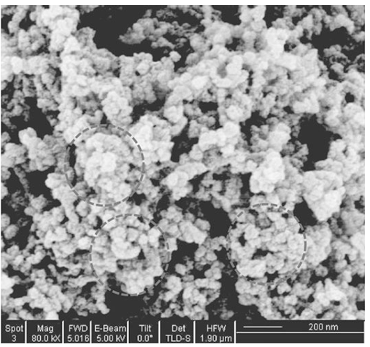

Yu, H. M., Schumacher, J. O., Zobel, M., & C. Hebling. (2005). Analysis of membrane electrode assembly (MEA) by environmental scanning electron microscope (ESEM). *Journal of Power Sources*, *145*(2), 216–222. <https://doi.org/10.1016/j.jpowsour.2004.12.069>

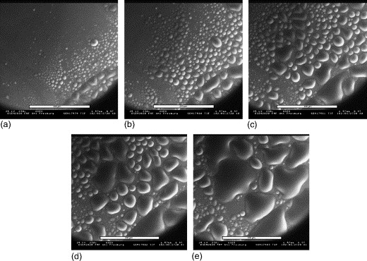 The process of water droplet formation on Nafion® 117.

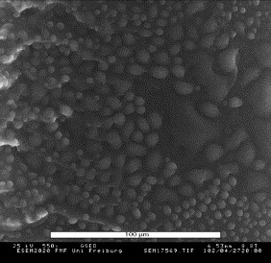

Fig. 2. Cross section of Nafion® 117 in wet mode.

Zhao, J., Samaneh Shahgaldi, Li, X., & Liu, Z. S. (2018). Experimental Observations of Microstructure Changes in the Catalyst Layers of Proton Exchange Membrane Fuel Cells under Wet-Dry Cycles. *Journal of the Electrochemical Society*, *165*(6), F3337–F3345. <https://doi.org/10.1149/2.0391806jes>

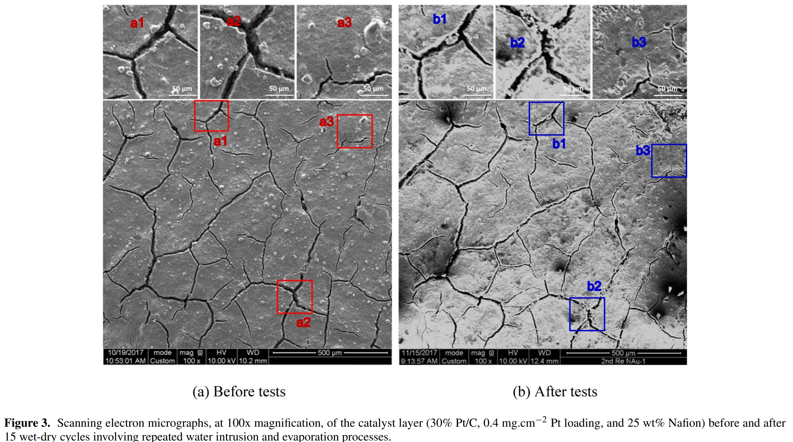

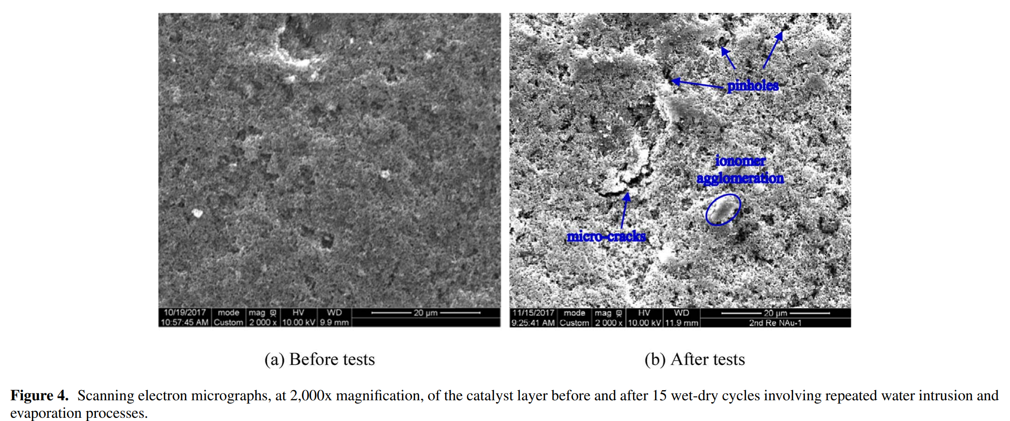

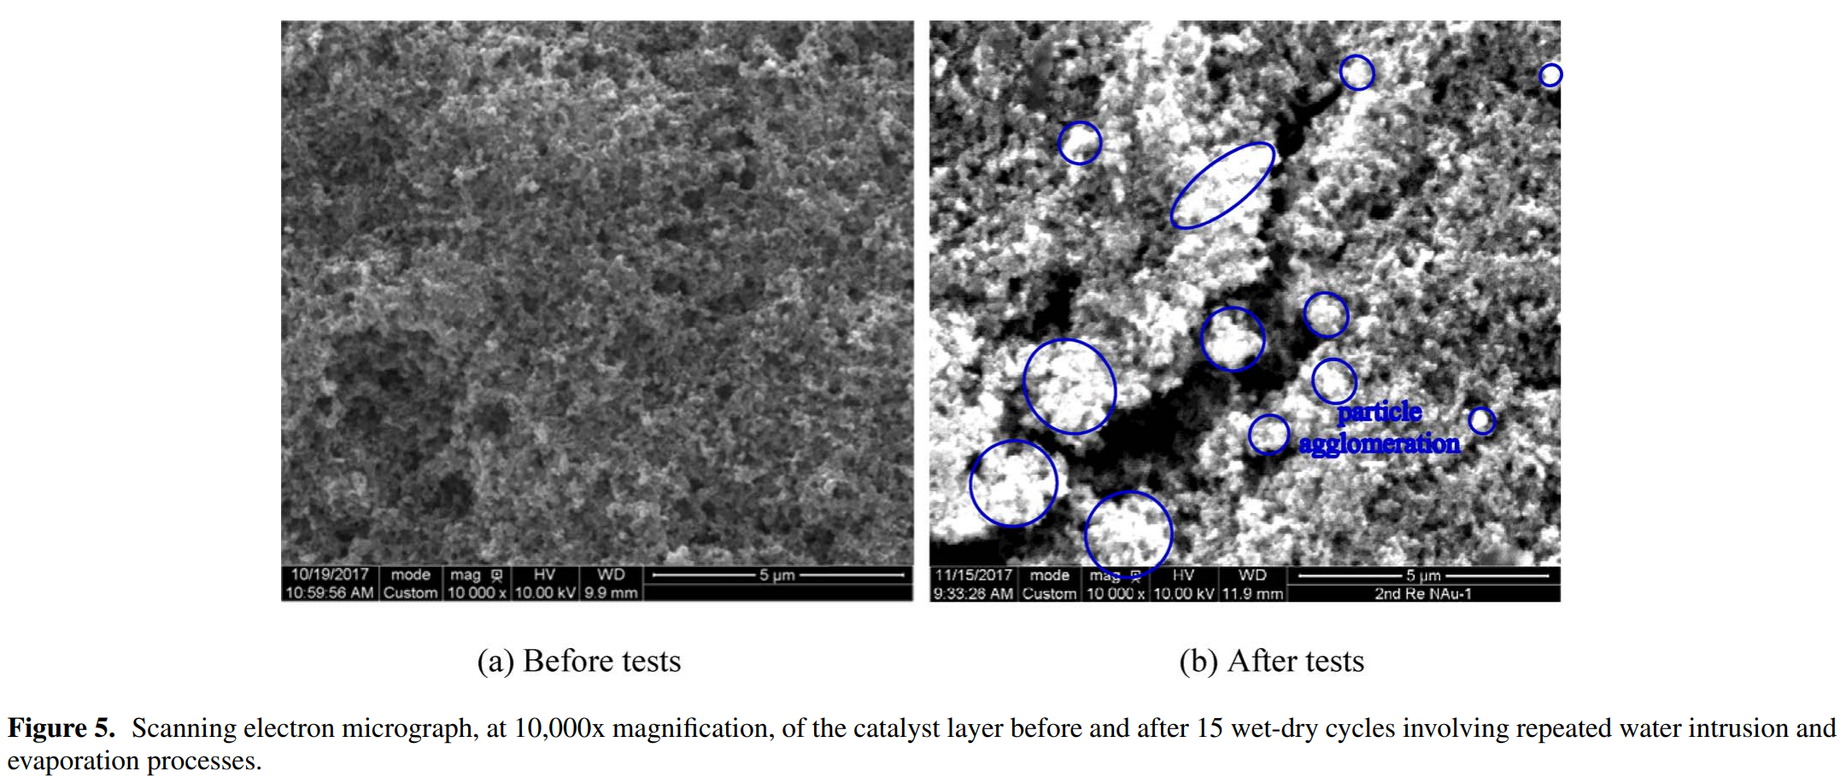

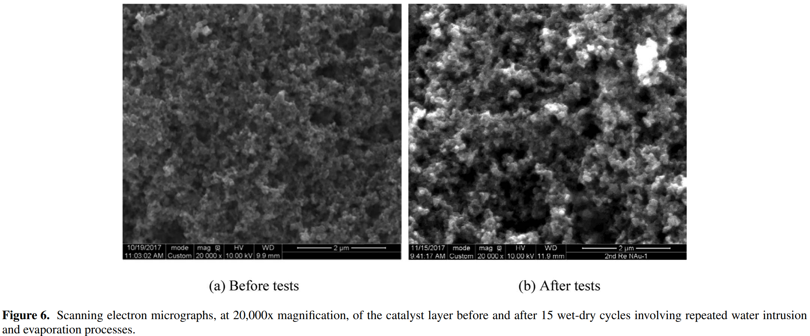

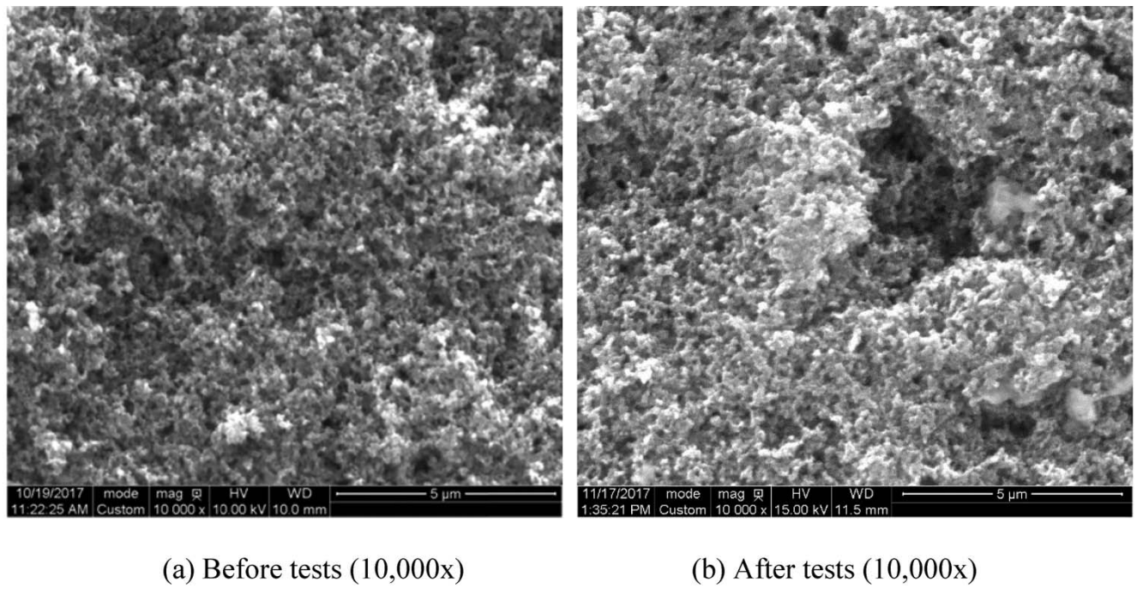

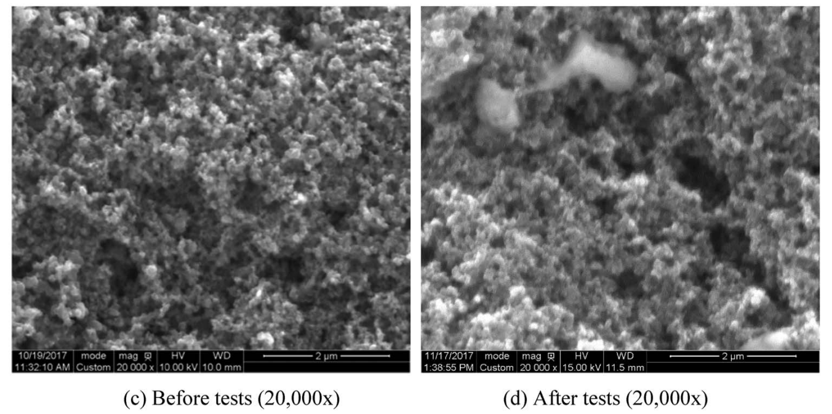

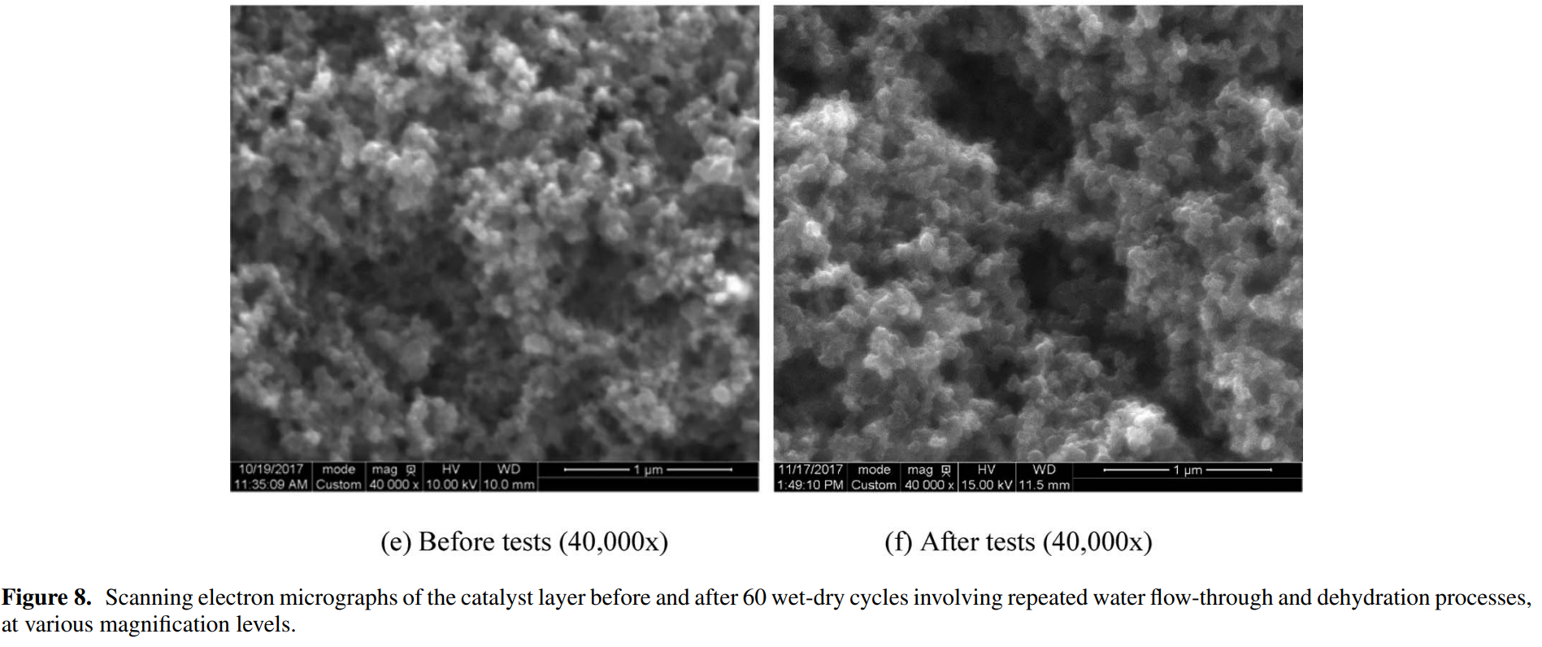

Adnan Ozden, Samaneh Shahgaldi, Zhao, J., Li, X., & Feridun Hamdullahpur. (2017). Assessment of graphene as an alternative microporous layer material for proton exchange membrane fuel cells. *Fuel*, *215*, 726–734. <https://doi.org/10.1016/j.fuel.2017.11.109>

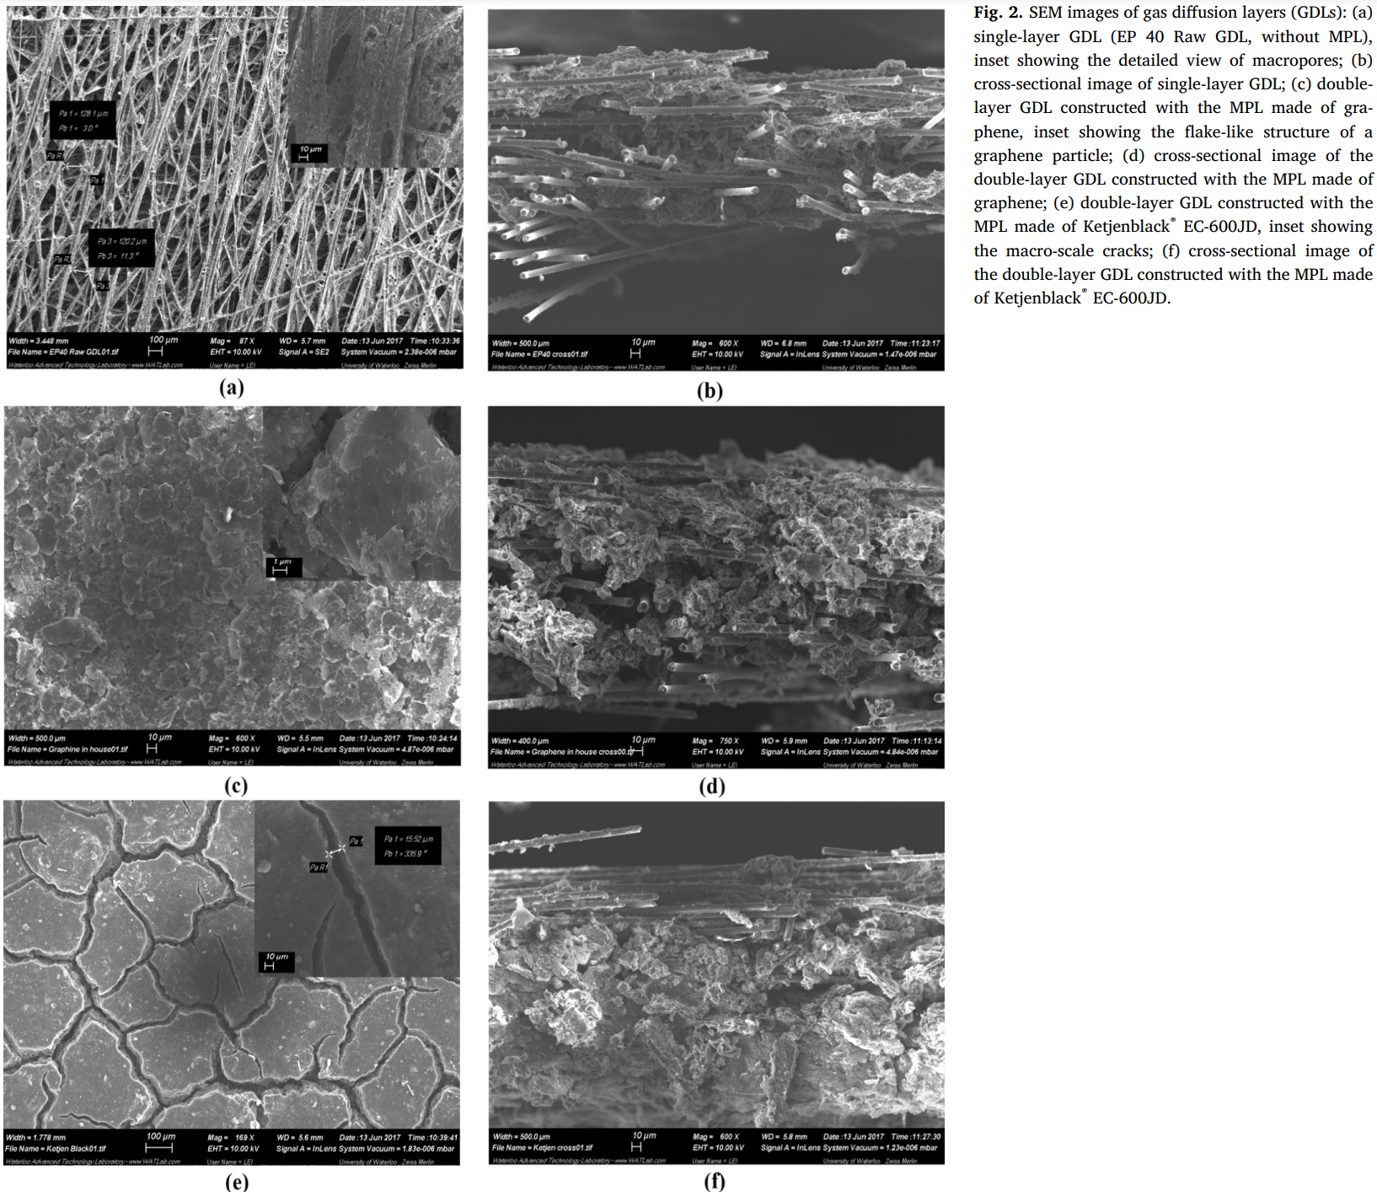

‌

Park, Y.-C., Haruki Tokiwa, Katsuyoshi Kakinuma, Watanabe, M., & Uchida, M. (2016). Effects of carbon supports on Pt distribution, ionomer coverage and cathode performance for polymer electrolyte fuel cells. *Journal of Power Sources*, *315*, 179–191. <https://doi.org/10.1016/j.jpowsour.2016.02.091>

‌

